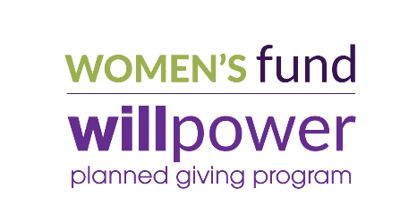
WILLPOWER PLANNED GIVING
STATEMENT OF INTENT

As an indication of my/our desire to provide a legacy of support to women and girls in the Fox Valley, I/we hereby inform the Women’s Fund for the Fox Valley Region, Inc. that I/we have made a provision for a gift in my/our estate plan. I/we understand that this commitment is revocable and can be modified by me/us at any time.
Donor Information

Name(s):

Address:
 | Street Address | Apartment/Unit #

 | City | State | ZIP Code

Email:

Phone 1: |  | ☐ m ☐ h | Phone 2: |  | ☐ m ☐ h

Donor Recognition

☐ Yes, you may recognize me/us in donor lists and at events. Please list my/our name as follows:

☐ I/We prefer to remain anonymous during our lifetimes, but you may recognize me/us after my/our gift matures.

☐ I/We prefer to remain anonymous.
Signature

Signature | Date

Signature | Date

Women’s Fund for the Fox Valley Region, Inc. is a 501(c)(3) organization.
Federal Tax ID 20-3096562

Description of Gift to Women’s Fund

☐ | Bequest through Will or revocable trust

☐ | Percentage of estate: |  | %
☐ | Specific amount $

☐ | The Women’s Fund is listed as a beneficiary of:

☐ | Retirement plan

☐ | IRA

☐ | Life Insurance

☐ | Charitable Gift Annuity

☐ | Charitable Trust

☐ | With the understanding that values are subject to change, in today’s dollars,
 | I/we estimate the value of my/our gift to be approximately | $
 | I/We understand that, by stating an amount, my/our estate is not legally bound by this statement and I/we may choose to add, subtract or revoke this bequest at any time, at my/our sole discretion.
Purpose of Gift

☐ | This gift is to be unrestricted and may be used where the need is greatest at the Women’s Fund.

☐ | I/We wish to specify that this gift be used to support the following project(s) or purpose(s):

☐ | Please contact me to discuss the opportunities listed above.

Please tell us why the Women’s Fund is important to you:

